https://www.baeldung.com/java-8-comparator-comparing

Guide to Java 8 Comparator.comparing()
Last modified: April 4, 2018
by baeldung
- Java+
- Java 8

I just announced the new Spring Boot 2 material, coming in REST With Spring:
>> CHECK OUT THE COURSE

1. Overview
Java 8 introduced several enhancements to the Comparator interface, including a handful of static functions that are of great utility when coming up with a sort order for collections.
Java 8 lambdas can be leveraged effectively with the Comparator interface as well. A detailed explanation of lambdas and Comparator can be found here, and a chronicle on sorting and applications of Comparator can be found here.
In this tutorial, we will explore several functions introduced for the Comparator interface in Java 8.

2. Getting Started

2.1. Sample Bean Class
For the examples in this article, let’s create an Employee bean and use its fields for comparing and sorting purposes:
1  2  3  4  5  6  7  8 | public class Employee {  String name;  int age;  double salary;  long mobile;  // constructors, getters & setters  }

2.2. Our Testing Data
Let’s also create an array of employees that will be used to store the results of our type in various test cases throughout the article:
1 | employees = new Employee[] { ... };
The initial ordering of elements of employees will be:
1  2  3 | [Employee(name=John, age=25, salary=3000.0, mobile=9922001),  Employee(name=Ace, age=22, salary=2000.0, mobile=5924001),  Employee(name=Keith, age=35, salary=4000.0, mobile=3924401)]
Throughout the article, we’ll be sorting above Employee array using different functions.
For test assertions, we’ll use a set of pre-sorted arrays that we will compare to our sort results (i.e., the employees array) for different scenarios.
Let’s declare a few of these arrays:
1  2  3  4  5  6  7  8 | @Before  public void initData() {  sortedEmployeesByName = new Employee[] {...};  sortedEmployeesByNameDesc = new Employee[] {...};  sortedEmployeesByAge = new Employee[] {...};  // ...  }
Like always, feel free to refer our GitHub link for the complete code.

3. Using Comparator.comparing
This section covers variants of the Comparator.comparing static function.

3.1. Key Selector Variant
The Comparator.comparing static function accepts a sort key Function and returns a Comparator for the type which contains the sort key:
1  2 | static <T,U extends Comparable<? super U>> Comparator<T> comparing(  Function<? super T,? extends U> keyExtractor)
To see this in action, let’s use the name field in Employee as the sort key and pass its method reference as an argument of type Function. The Comparator returned from the same is used for sorting:
1  2  3  4  5  6  7  8  9 | @Test  public void whenComparing_thenSortedByName() {  Comparator<Employee> employeeNameComparator  = Comparator.comparing(Employee::getName);  Arrays.sort(employees, employeeNameComparator);  assertTrue(Arrays.equals(employees, sortedEmployeesByName));  }
As you can see, the employees array values are sorted by name as a result of the sort:
1  2  3 | [Employee(name=Ace, age=22, salary=2000.0, mobile=5924001),  Employee(name=John, age=25, salary=3000.0, mobile=9922001),  Employee(name=Keith, age=35, salary=4000.0, mobile=3924401)]

3.2. Key Selector and Comparator Variant
There is another option that facilitates overriding the natural ordering of the sort key by providing the Comparator that creates a custom ordering for the sort key:
1  2  3 | static <T,U> Comparator<T> comparing(  Function<? super T,? extends U> keyExtractor,  Comparator<? super U> keyComparator)
Let’s modify the test above, overriding the natural order of sorting by the name field by providing a Comparator for sorting the names in descending order as the second argument to Comparator.comparing:
1  2  3  4  5  6  7  8  9  10  11  12 | @Test  public void whenComparingWithComparator_thenSortedByNameDesc() {  Comparator<Employee> employeeNameComparator  = Comparator.comparing(  Employee::getName, (s1, s2) -> {  return s2.compareTo(s1);  });  Arrays.sort(employees, employeeNameComparator);  assertTrue(Arrays.equals(employees, sortedEmployeesByNameDesc));  }
As you can see, the results are sorted in descending order by name:
1  2  3 | [Employee(name=Keith, age=35, salary=4000.0, mobile=3924401),  Employee(name=John, age=25, salary=3000.0, mobile=9922001),  Employee(name=Ace, age=22, salary=2000.0, mobile=5924001)]

3.3. Using Comparator.reversed
When invoked on an existing Comparator, the instance method Comparator.reversed returns a new Comparator that reverses the sort order of the original.
Let’s use the Comparator that sorts the employees by name and reverse it so that employees are sorted in descending order of the name:
1  2  3  4  5  6  7  8  9 | @Test  public void whenReversed_thenSortedByNameDesc() {  Comparator<Employee> employeeNameComparator  = Comparator.comparing(Employee::getName);  Comparator<Employee> employeeNameComparatorReversed  = employeeNameComparator.reversed();  Arrays.sort(employees, employeeNameComparatorReversed);  assertTrue(Arrays.equals(employees, sortedEmployeesByNameDesc));  }
The results are sorted in descending order by name:
1  2  3 | [Employee(name=Keith, age=35, salary=4000.0, mobile=3924401),  Employee(name=John, age=25, salary=3000.0, mobile=9922001),  Employee(name=Ace, age=22, salary=2000.0, mobile=5924001)]

3.4. Using Comparator.comparingInt
There is also a function Comparator.comparingInt which does the same thing as Comparator.comparing, but it takes only int selectors. Let’s try this with an example where we order employees by age:
1  2  3  4  5  6  7  8  9 | @Test  public void whenComparingInt_thenSortedByAge() {  Comparator<Employee> employeeAgeComparator  = Comparator.comparingInt(Employee::getAge);  Arrays.sort(employees, employeeAgeComparator);  assertTrue(Arrays.equals(employees, sortedEmployeesByAge));  }
Let’s see how the employees array values are ordered after the sort:
1  2  3 | [Employee(name=Ace, age=22, salary=2000.0, mobile=5924001),  Employee(name=John, age=25, salary=3000.0, mobile=9922001),  Employee(name=Keith, age=35, salary=4000.0, mobile=3924401)]

3.5. Using Comparator.comparingLong
Similar to what we did for int keys, let’s see an example using Comparator.comparingLong to consider a sort key of type long by ordering the employees array by the mobile field:
1  2  3  4  5  6  7  8  9 | @Test  public void whenComparingLong_thenSortedByMobile() {  Comparator<Employee> employeeMobileComparator  = Comparator.comparingLong(Employee::getMobile);  Arrays.sort(employees, employeeMobileComparator);  assertTrue(Arrays.equals(employees, sortedEmployeesByMobile));  }
Let’s see how the employees array values are ordered after the sort with mobile as the key:
1  2  3 | [Employee(name=Keith, age=35, salary=4000.0, mobile=3924401),  Employee(name=Ace, age=22, salary=2000.0, mobile=5924001),  Employee(name=John, age=25, salary=3000.0, mobile=9922001)]

3.6. Using Comparator.comparingDouble
Again, similar to what we did for int and long keys, let’s see an example using Comparator.comparingDouble to consider a sort key of type double by ordering the employees array by the salary field:
1  2  3  4  5  6  7  8  9 | @Test  public void whenComparingDouble_thenSortedBySalary() {  Comparator<Employee> employeeSalaryComparator  = Comparator.comparingDouble(Employee::getSalary);  Arrays.sort(employees, employeeSalaryComparator);  assertTrue(Arrays.equals(employees, sortedEmployeesBySalary));  }
Let’s see how the employees array values are ordered after the sort with salary as the sort key:
1  2  3 | [Employee(name=Ace, age=22, salary=2000.0, mobile=5924001),  Employee(name=John, age=25, salary=3000.0, mobile=9922001),  Employee(name=Keith, age=35, salary=4000.0, mobile=3924401)]

4. Considering Natural Order in Comparator
The natural order is defined by the behavior of the Comparable interface implementation. More information about the difference between Comparator and uses of the Comparableinterface can be found in this article.
Let’s implement Comparable in our Employee class so that we can try the natrualOrder and reverseOrder functions of the Comparator interface:
1  2  3  4  5  6  7  8 | public class Employee implements Comparable<Employee>{  // ...  @Override  public int compareTo(Employee argEmployee) {  return name.compareTo(argEmployee.getName());  }  }

4.1. Using Natural Order
The naturalOrder function returns the Comparator for the return type mentioned in the signature:
1 | static <T extends Comparable<? super T>> Comparator<T> naturalOrder()
Given the above logic to compare employees based on name field, let’s use this function to obtain to a Comparator which sorts the employees array in natural order:
1  2  3  4  5  6  7  8  9 | @Test  public void whenNaturalOrder_thenSortedByName() {  Comparator<Employee> employeeNameComparator  = Comparator.<Employee> naturalOrder();  Arrays.sort(employees, employeeNameComparator);  assertTrue(Arrays.equals(employees, sortedEmployeesByName));  }
Let’s see how the employees array values are ordered after the sort:
1  2  3 | [Employee(name=Ace, age=22, salary=2000.0, mobile=5924001),  Employee(name=John, age=25, salary=3000.0, mobile=9922001),  Employee(name=Keith, age=35, salary=4000.0, mobile=3924401)]

4.2. Using Reverse Natural Order
Similar to naturalOrder, let’s use the reverseOrder method to generate a Comparator which will produce a reverse ordering of employees to the one in the naturalOrder example:
1  2  3  4  5  6  7  8  9 | @Test  public void whenReverseOrder_thenSortedByNameDesc() {  Comparator<Employee> employeeNameComparator  = Comparator.<Employee> reverseOrder();  Arrays.sort(employees, employeeNameComparator);  assertTrue(Arrays.equals(employees, sortedEmployeesByNameDesc));  }
Let’s see how the employees array values are ordered after the sort:
1  2  3 | [Employee(name=Keith, age=35, salary=4000.0, mobile=3924401),  Employee(name=John, age=25, salary=3000.0, mobile=9922001),  Employee(name=Ace, age=22, salary=2000.0, mobile=5924001)]

5. Considering Null Values in Comparator
This section covers functions nullsFirst and nullsLast, which consider null values in ordering and keep the null values at the beginning or end of the ordering sequence.

5.1. Considering Null First
Let’s randomly insert null values in employees array:
1  2  3  4  5 | [Employee(name=John, age=25, salary=3000.0, mobile=9922001),  null,  Employee(name=Ace, age=22, salary=2000.0, mobile=5924001),  null,  Employee(name=Keith, age=35, salary=4000.0, mobile=3924401)]
The nullsFirst function will return a Comparator that keeps all nulls at the beginning of the ordering sequence:
1  2  3  4  5  6  7  8  9  10  11  12  13  14 | @Test  public void whenNullsFirst_thenSortedByNameWithNullsFirst() {  Comparator<Employee> employeeNameComparator  = Comparator.comparing(Employee::getName);  Comparator<Employee> employeeNameComparator_nullFirst  = Comparator.nullsFirst(employeeNameComparator);  Arrays.sort(employeesArrayWithNulls,  employeeNameComparator_nullFirst);  assertTrue(Arrays.equals(  employeesArrayWithNulls,  sortedEmployeesArray_WithNullsFirst));  }
Let’s see how the employees array values are ordered after the sort:
1  2  3  4  5 | [null,  null,  Employee(name=Ace, age=22, salary=2000.0, mobile=5924001),  Employee(name=John, age=25, salary=3000.0, mobile=9922001),  Employee(name=Keith, age=35, salary=4000.0, mobile=3924401)]

5.2. Considering Null Last
The nullsLast function will return a Comparator that keeps all nulls at the end of the ordering sequence:
1  2  3  4  5  6  7  8  9  10  11  12 | @Test  public void whenNullsLast_thenSortedByNameWithNullsLast() {  Comparator<Employee> employeeNameComparator  = Comparator.comparing(Employee::getName);  Comparator<Employee> employeeNameComparator_nullLast  = Comparator.nullsLast(employeeNameComparator);  Arrays.sort(employeesArrayWithNulls, employeeNameComparator_nullLast);  assertTrue(Arrays.equals(  employeesArrayWithNulls, sortedEmployeesArray_WithNullsLast));  }
Let’s see how the employees array values are ordered after the sort:
1  2  3  4  5 | [Employee(name=Ace, age=22, salary=2000.0, mobile=5924001),  Employee(name=John, age=25, salary=3000.0, mobile=9922001),  Employee(name=Keith, age=35, salary=4000.0, mobile=3924401),  null,  null]

6. Using Comparator.thenComparing
The thenComparing function lets you set up lexicographical ordering of values by provisioning multiple sort keys in a particular sequence.
Let’s consider another array of Employee class:
1 | someMoreEmployees = new Employee[] { ... };
Consider the following sequence of elements in the above array:
1  2  3  4 | [Employee(name=Jake, age=25, salary=3000.0, mobile=9922001),  Employee(name=Jake, age=22, salary=2000.0, mobile=5924001),  Employee(name=Ace, age=22, salary=3000.0, mobile=6423001),  Employee(name=Keith, age=35, salary=4000.0, mobile=3924401)]
Let’s write a sequence of comparisons as age followed by the name and see the ordering of this array:
1  2  3  4  5  6  7  8  9  10 | @Test  public void whenThenComparing_thenSortedByAgeName(){  Comparator<Employee> employee_Age_Name_Comparator  = Comparator.comparing(Employee::getAge)  .thenComparing(Employee::getName);  Arrays.sort(someMoreEmployees, employee_Age_Name_Comparator);  assertTrue(Arrays.equals(someMoreEmployees, sortedEmployeesByAgeName));  }
Here the ordering will be done by age, and for the values with the same age, ordering will be done by name. Let’s observe this in the sequence we receive after sorting:
1  2  3  4 | [Employee(name=Ace, age=22, salary=3000.0, mobile=6423001),  Employee(name=Jake, age=22, salary=2000.0, mobile=5924001),  Employee(name=Jake, age=25, salary=3000.0, mobile=9922001),  Employee(name=Keith, age=35, salary=4000.0, mobile=3924401)]
Let’s use the other version of thenComparing that is thenComparingInt, by changing the lexicographical sequence to name followed by age:
1  2  3  4  5  6  7  8  9  10  11 | @Test  public void whenThenComparing_thenSortedByNameAge() {  Comparator<Employee> employee_Name_Age_Comparator  = Comparator.comparing(Employee::getName)  .thenComparingInt(Employee::getAge);  Arrays.sort(someMoreEmployees, employee_Name_Age_Comparator);  assertTrue(Arrays.equals(someMoreEmployees,  sortedEmployeesByNameAge));  }
Let’s see how the employees array values are ordered after the sort:T
1  2  3  4 | [Employee(name=Ace, age=22, salary=3000.0, mobile=6423001),  Employee(name=Jake, age=22, salary=2000.0, mobile=5924001),  Employee(name=Jake, age=25, salary=3000.0, mobile=9922001),  Employee(name=Keith, age=35, salary=4000.0, mobile=3924401)]
Similarly, there are functions thenComparingLong and thenComparingDouble for using longand double sorting keys.

7. Conclusion
This article is a guide to several features introduced in Java 8 for the Comparator interface.
As usual, the source code can be found over on Github.

https://www.webucator.com/how-to/how-use-the-comparatorcomparing-method-java-8.cfm

How to Use the Comparator.comparing Method in Java 8
The Comparator.comparing method, introduced in Java 8, returns a Comparator object that will use the specified field as the sort key. The Comparator interface is a functional interface in Java 8, and the method implemented is the compare method. Therefore, the compare method is implemented by the comparingmethod using the specified key. To learn how to use the Comparator.comparing method, follow these seven steps.
- Open your text editor and create a new file that will contain the musical instrument class that ultimately will be sorted. Type in the following Java statements:
- public class MusicalInstrument {
- private String name;
- private String type;
- public MusicalInstrument(String name, String type) {
- setName(name);
- setType(type);
- }
- public String getName() {
- return name;
- }
- public void setName (String name) {
- this.name=name;
- }
- public String getType() {
- return type;
- }
- public void setType (String type) {
- this.type=type;
- }
- public String toString() {
- return name + " is a " + type + " instrument";
- }
}
This is a straightforward Java bean that contains two properties: musical instrument name (e.g., trumpet) and type of musical instrument (e.g., brass). I have highlighted the two properties in the image below:
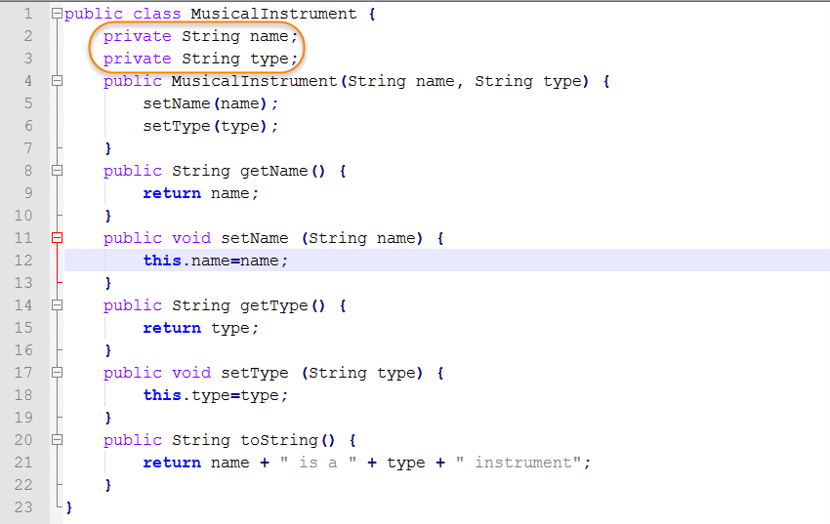
- Save your file as MusicalInstrument.java.
- Open a command prompt and navigate to the directory containing your new Java program. Then type in the command to compile the source and hit Enter.
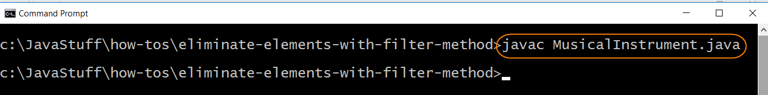
- Open your text editor and create the Java program that will demonstrate the use of the Comparator.comparing method. Type in the following Java statements:

- import java.util.stream.*;
- import java.util.*;
- public class UseComparatorcomparingMethod {
- private static List musicalInstruments=new ArrayList<>();
- static {
- musicalInstruments.add(new MusicalInstrument("Trumpet","brass"));
- musicalInstruments.add(new MusicalInstrument("Tuba","brass"));
- musicalInstruments.add(new MusicalInstrument("Timpani","percussion"));
- musicalInstruments.add(new MusicalInstrument("Piano","keyboard"));
- }
- public static void main (String args[]) {
- System.out.println("Musical instruments in the collection sorted by name:");
- Collections.sort(musicalInstruments, Comparator.comparing((MusicalInstrument instrument) -> instrument.getName()));
- musicalInstruments.stream().forEach(System.out::println);

- System.out.println("Musical instruments in the collection sorted by type:");
- Collections.sort(musicalInstruments, Comparator.comparing((MusicalInstrument instrument) -> instrument.getType()));
- musicalInstruments.stream().forEach(instrument->System.out.println(instrument));
- }
}
The stream will be created from the ArrayList that is defined on line 4. Note that a static block is used to add elements to the ArrayList. A static block is executed one time when the program is loaded into memory. The ArrayList will be sorted by Collections.sort. This static method accepts an ArrayList and a Comparator object. Note that the Comparator object will be returned by the comparing method. The parameter passed to the comparing method is a lambda expression that determines the sort field. The musical instrument name is passed to the first comparing method and the musical instrument type is passed to the second comparing method. I have highlighted the comparing method calls below:
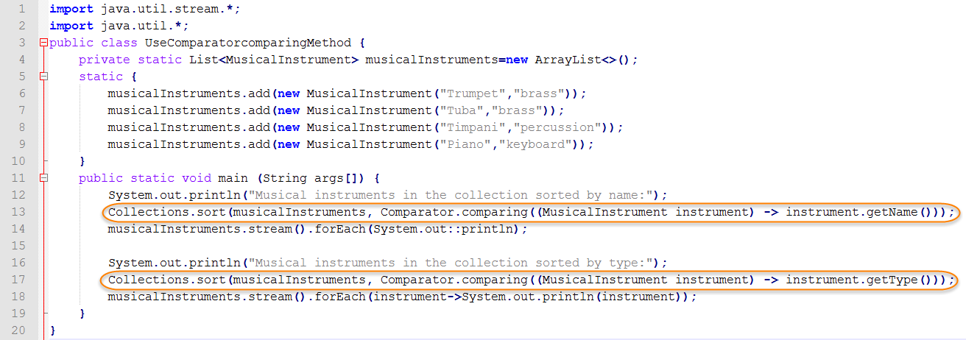
- Save your file as UseComparatorcomparingMethod.java.
- Open a command prompt and navigate to the directory containing your new Java program. Then type in the command to compile the source and hit Enter.
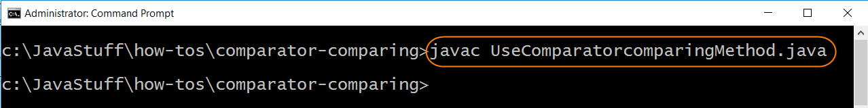
- You are ready to test your Java program. Type in the command to run the Java runtime launcher and hit Enter. The output displays the musical instruments sorted first by name and then by type.
